W3 PRACTICE
JS – ES6 Arrays + NPM

 At the end of this practice, you should be able to…
- Create, update and remove items in array
- Use the arrow syntax to define functions as parameters: f = () => {}
- Use ES6 arrays methods such as: find, map, filter, foreach for effective array operations

 How to work?

BEFORE THE PRACTICE
- First watch and understand the following pages and videos:
basic operations, map, find, filter, foreach
video 1, video 2

- Then complete the following quiz (you can re-do it until you have 100% score)
https://forms.gle/56qZcmEbHnsuQzKE6

DURING THE PRACTICE
- To start the practice. download the start code from Google classroom

How to submit?
- Create a new folder on your GitHub repository with the name of this practice:
Ex: C1-S2-PRACTICE
- Push your final code on this GitHub repository (if you are lost, follow this tutorial)
- Finally, submit on Google classroom your GitHub repository URL
Ex : https://github.com/ronan/react-course/C2-S1-PRACTICE

About Node JS


What is Node.js?
Node.js is a JavaScript runtime environment that can run on Windows, Linux, Unix, macOS, and more.
Node.js is able to execute JavaScript code outside a web browser.
We need to be able to run our JS and our ReactJS code using Node.js during this course.

 How to run JavaScript with Node.js?

Check node is installed
node –v
If not, you need to re-install Node or update it.

Create a new JS file, index.js with:
console.log(“Hello !”)

Open the VS code terminal and run
node ./index.js

 Are you lost?
You can read the following documentation:

https://nodejs.org/en/learn/getting-started/differences-between-nodejs-and-the-browser
https://nodejs.org/en/download

UNDERSTAND THE CONCEPTS…
Before starting the exercise, complete this table with some code examples, to show you understood the theory.
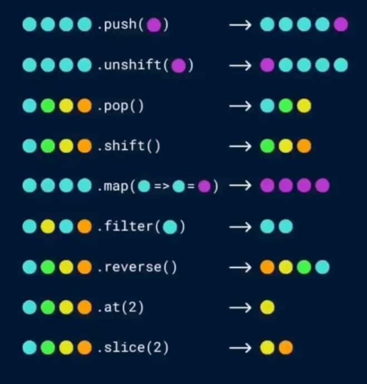

Let's say we have the following start code:
Let numbers = [1, 2, 3, 4, 5]

Usage | Example of code
Add an element at the end of the array | numbers.push()
Loop on all array elements | numbers.forEach(number => {  console.log(number);  })
Access to the array element with its index | let num = numbers.at()  or  numbers[]
Remove an array element with its index | numbers.splice(startIndex, deleteCount)
Filter array elements | let biggerThanThree = numbers.filter(num => num >3 );.
Transform each array element by applying a function on them | let plusOne = numbers.map(num => num + 1);

EXERCISE 1

Your task is to add the missing logic to a transformToObjects() function that should transform a list of numbers into a list of objects.

In the newly returned array, every object must have a val key and the input array's number as a value.

/**
* Creates transform a list of numbers into a list of objects.
* @param {array} listOfNumbers - a list of numbers
* @returns a list of objects
*/
function transformToObjects(listOfNumbers) {
// Write your code here
let result = listOfNumbers.map(number => {
return { val: number };
});

return result;
}

Examples of inputs/outputs:
INPUT | OUTPUT
[1, 2, 3] | [{val: 1}, {val: 2}, {val: 3}]
[44] | [{val: 44}]

EXERCISE 2
We are managing a data structure of students - representing a student with first Name and age properties.

const STUDENTS_DATA = [
{ firstName: "An", age: 20 },
{ firstName: "Bình", age: 22 },
{ firstName: "Cẩm", age: 21 },
{ firstName: "An", age: 19 }, // Duplicate first name !
];

The updateStudentAge function is supposed to update the age of a student his/her first name
However, some students have the same first name!



Your task is to update the data structure and the function to manage the last name and the batch, and fix our problem!
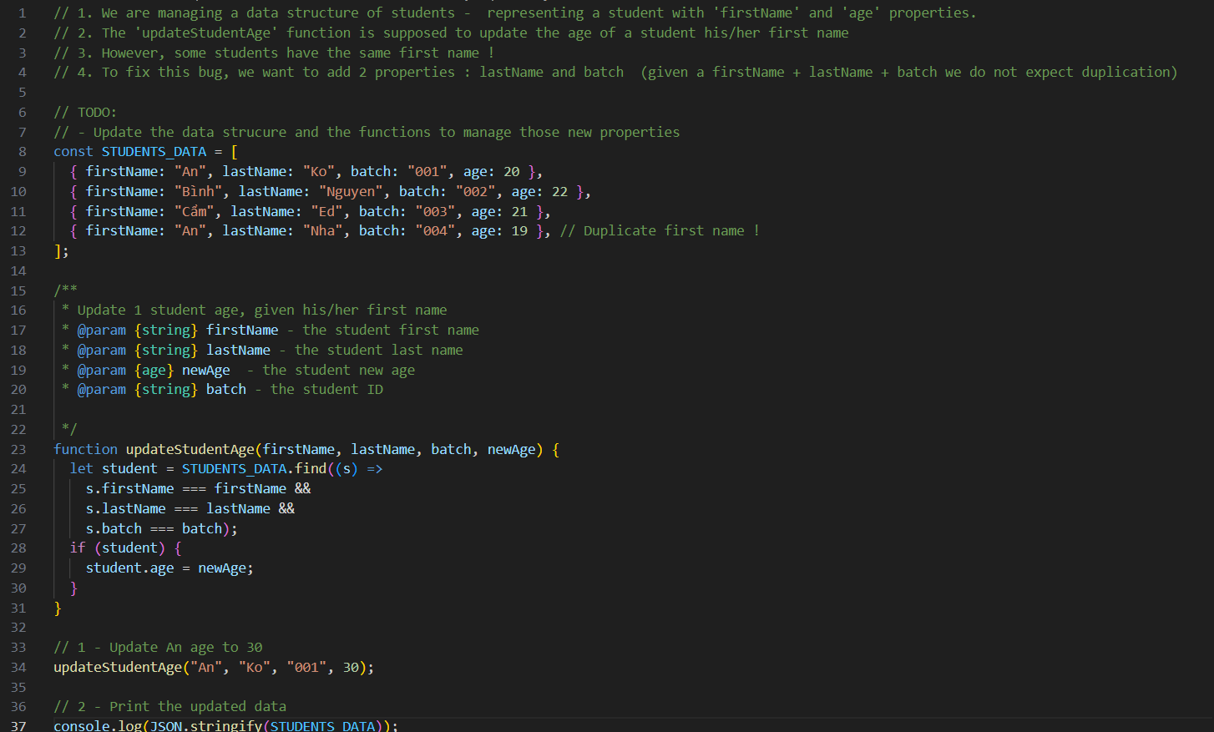

EXERCISE 3


In order to manage an online store, we have 2 data structures:

- A list of products in the shop: each product having a unique id, name and unit price
const PRODUCTS = [
{ id: 1, name: "Apple", price: 2.5 },
{ id: 2, name: "Banana", price: 1.5 },
{ id: 3, name: "Orange", price: 3 },
{ id: 4, name: "Rice", price: 1.5 },
{ id: 5, name: "Chocolate", price: 3 },
];

- A shopping cart: which contain the items the customer wants to buy and their quantity
const SHOPPING_CART = [
{ id: 1, quantity: 2 },
{ id: 3, quantity: 1 },
];

Q1 - Complete the getCartTotalAmount() function to get the total amount of the current shopping cart.

Example:
- The cart contains 2 apples and 1 orange:
const SHOPPING_CART = [
{ id: 1, quantity: 2 },
{ id: 3, quantity: 1 },
];

- Each apple costs 2.5 $
- Each orange costs 3 $
- The function return value shall be: 8 $

Q2 - Complete the addProductToCart() function to add a product to the shopping cartcart.

- If the product id already exists in the cart, just increment its quantity:

addProductToCart(1)
[{ id: 1, quantity: 2 }] ---> [{ id: 1, quantity: 3 }]

- If the product id does NOT exist in the cart, add a new item, with a quantity 1

addProductToCart(2)
[{ id: 1, quantity: 2 }] ---> [{ id: 1, quantity: 2 },{ id: 2, quantity: 1 }]

Q3 - Complete the removeProductFromCart() function to remove a product from the shopping cartcart.

- If the product id already exists in the cart, and quantity if >=2 : just decrement its quantity
removeProductToCart(1)
[{ id: 1, quantity: 2 }] ---> [{ id: 1, quantity: 3 }]

- if the product id already exists in the cart, and quantity is 1 : remove the item from the card

removeProductToCart(1) :
[{ id: 1, quantity: 1 }] ------> []

- if the product id does not exist in the cart, do nothing !

